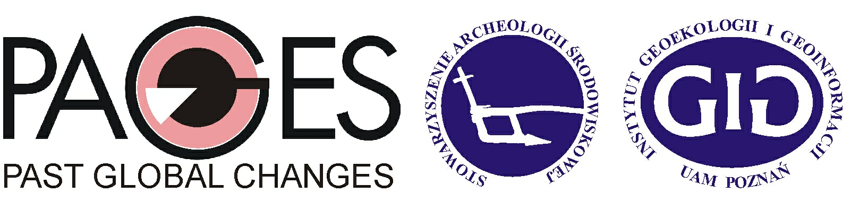

Rationale and workshop aims
The Geoarcheological Workshop follows the recent INQUA Loess Commission meeting – International Workshop, 6th Loess Seminar “Closing the gap – North Carpathian loess traverse in the Eurasian loess belt” – Wrocław 2011.

The PAGES-EuroGeoarcheo workshop main aim is to initiate scientific discussion on new challenges for geoarcheology in Central Europe preparing for new working group in range of PAGES. Special attention in this meeting is focused on actual stage of the environmental archaeology investigations in southern Poland and northern Czech and their implications for paleoclimatic changes versus new delimitations of the Quaternary. This workshop refers mainly to the Late Pleistocene and Paleolithic period – in the next meetings we intend to discuss climatic changes in the context of geoarcheological data in the Central Europe during the last 5ka.

Please note that the following questions will be addressed to: geologists, geomorphologists, paleoecologists and archeologists, mainly from Europe.

Temat/ Subject:

Geoarcheological Workshop – Actual stage of the environmental archaeology investigations in southern Poland and northern Czech and their implications for paleoclimatic changes versus new delimitations of the Quaternary

Organising committee:

Mirosław Makohonienko AMU-PAGES-SAS
Katarzyna Issmer AMU-PAGES-SAS
Iwona Hildebrandt-Radke AMU-SAS

Place:
Institute of Geoecology and Geoinformation, Adam Mickiewicz University Poznań, room 242 (Poznań, Dzięgielowa 27, Collegium Geographicum)

Term
wtorek, 25 października 2011/Tuesday, 25 October 2011

Numbers of lectures:7

20 min for each lecture (oral presentation 15 min + 5 min discussion)

Język/Language:English

Chairpersons: Michał Kobusiewicz & Mirosław Makohonienko

Programme:

 | Opening (11:00 - 11:15)
Keynote speakers:
Mirosław Makohonienko – Environmental Archeology – Man and Climate
Katarzyna Issmer – Paleoclimatic changes versus new delimitation of Quaternary
Michał Kobusiewicz – Challenges in Paleolithic investigations

Chairpersons: Teresa Madeyska, Maria Łanczont

Lectures:

1. | Andrzej Wiśniewski (11:15 - 11:35)  Late Middle Palaeolithic in southern Poland (MIS5d-3): a new look at old problems
2. | Jiri Chlachula (11:35 - 11:55) Geoarcheology of the initial peopling of the Morava-Dyje Basin, Czech Republic
3. | Tomasz Kalicki (11:55 - 12:15) Geoarchaeological studies of man-environment interaction in the upper Vistula river valleys – some examples
4. | Lenka Lisa (12:15 - 12:35) New results on the paleoclimate record of the Late Pleistocene cave sediments (Moravian Karst, Czech Republic); the case study based on mineral magnetic properties and facial analyses
5. | Adam Nadachowski, Krzysztof Stefaniak, Piotr Wojtal (12:35 - 12:55)  Patterns of magafaunal extinctions in southern Poland in the changing environment of Late Pleistocene
 | Coffee break 12:55 13:10
 | Chairpersons: Adam Nadachowski, Michał Kobusiewicz
Short poster session:
Maria Łanczont, Teresa Madeyska (13:10 13:25) Premises of the research project concerning the Palaeolithic oecumene study in pery- and meta-Carpathian region of Poland and Ukraine
6. | Dariusz Bobak (13:25 - 13:45) Chronology and synchronization of climate data for Middle to Upper Paleolithic transition
7. | Marta Połtowicz-Bobak (13:45 - 14:05) Environmet of the Final Paleolithic and Magdalenian peopling of the eastern part of Central Europe
8. | Issmer Katarzyna (14:05 - 14:25) Paleoclimatic changes versus new delimitation of Quternary
9. | Iwona Hildebrandt-Radke (14:25 - 14:45) Spatial analysis of the prehistoric and early historic settlement in the region of the Middle Obra River using GIS methods

Lunch break (14:45-16:05)

Open discussion (16:05-17:45)
New challenges for geoarcheology in Central Europe preparing for new working group in PAGES
Moderators: Katarzyna Issmer, Mirosław Makohonienko, Andrzej Wiśniewski

Organizatorzy i wykładowcy / Organisers and lecturers

Dr. Dariusz BOBAK  Uniwersytet Rzeszowski, Instytut Archeologii  Zakład Archeologii Epoki Kamienia  ul. Hoffmanowej 8, 35-016 Rzeszów |  | University of Rzeszów  Institute of Archaeology  Department of Stone Age Archaeology
Doc. PhDr. Jiří CHLACHULA, Ph.D. et Ph.D.  Laboratory for palaeoecology FLKM  Tomas Bata University in Zlin  nam.T.G.M. 5555  CZ 760 01 Zlín,  e-mail: Altay@seznam.cz | 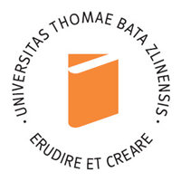 | Tomas Bata University in Zlin  Laboratory for palaeoecology FLKM
Dr Iwona HILDEBRANDT-RADKE  Uniwersytet im. Adama Mickiewicza  Instytut Geoekologii i Geoinformacji  Zakład Geologii i Paleogeografii Czwartorzędu  ul. Dzięgielowa 27, 61-680 Poznań  e-mail: hilde@amu.edu.pl  tel.: +48-61- 829 6199 | 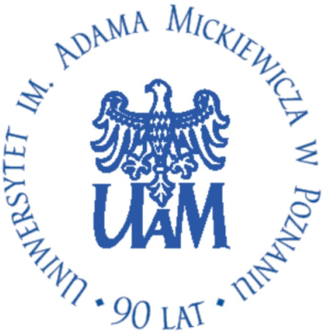 | Adam Mickiewicz University in Poznań  Institute of Geoecology and Geoinformation  Department of Quaternary Geology and Palaeogeography
Dr Katarzyna ISSMER  Uniwersytet im. Adama Mickiewicza  Instytut Geoekologii i Geoinformacji  Zakład Geomorfologii  ul. Dzięgielowa 27, 61-680 Poznań  e-mail: kissmer@amu.edu.pl  tel.: +48-61-829 6203 |  | Adam Mickiewicz University in Poznań  Institute of Geoecology and Geoinformation  Department of Geomorphology
Prof. dr hab. Michał KOBUSIEWICZ  Instytut Archeologii i Etnologii PAN  Oddział w Poznaniu  ul. Rubież 46, 61-612 Poznań  e-mail: kobusiewicz@iaepan.poznan.pl  tel. +48-61- 8279 766 | 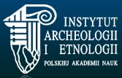 | Institute of Archaeology and Ethnology  Polish Academy of Sciences
Dr. Lenka LISA  Akademie věd České republiky  Sekce věd o Zemi, Geologický ústav  Rozvojova 269, 165 02 Prague 6 - Lysolaje  E-mail: lisa@gli.cas.cz  Tel.: +420 607 706 585 or +420 233 087 252 |  | Academy of Sciences of the Czech Republic  Institute of Geology
Prof. UAM dr hab. Mirosław MAKOHONIENKO  Uniwersytet im. Adama Mickiewicza  Instytut Geoekologii i Geoinformacji  Zakład Geologii i Paleogeografii Czwartorzędu  ul. Dzięgielowa 27, 61-680 Poznań  e-mail: makoho@amu.edu.pl  tel. +48-12- 422 19 01 |  | Adam Mickiewicz University in Poznań  Institute of Geoecology and Geoinformation  Department of Quaternary Geology and Palaeogeography
Prof. dr hab. Adam NADACHOWSKI Instytut Systematyki i Ewolucji Zwierząt PAN  ul. Sławkowska 17, 31-016 Kraków  e-mail: nadachowski@isez.pan.krakow.pl  tel. +48-61-829 6215 |  | Institute of Systematics and Evolution of Animals  Polish Academy of Sciences
Dr Marta POŁTOWICZ-BOBAK  Uniwersytet Rzeszowski, Instytut Archeologii  Zakład Archeologii Epoki Kamienia  ul. Hoffmanowej 8, 35-016 Rzeszów  e-mail:  tel. +48-17-872 1587 |  | University of Rzeszów  Institute of Archaeology  Department of Stone Age Archaeology
Dr Andrzej WIŚNIEWSKI  Zakład Archeologii Epoki Kamienia  Instytut Archeologii  Uniwersytet Wrocławski  ul. Szewska 48, 50-139 Wrocław  e-mail: andrzej.wisniewski@archeo.uni.wroc.pl  tel. +48-71-3752 724 | 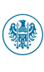 | University of Wrocław  Institute of Archaeology  Department of Stone Age Archaeology

